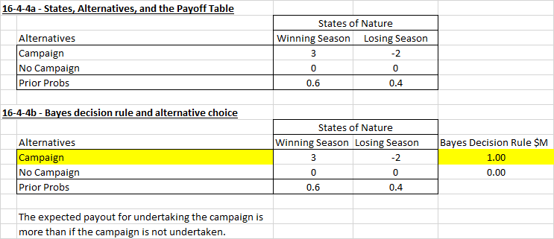

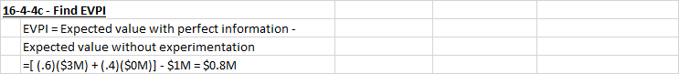

**16.4.4 d)** Conditional probabilitiesJoint probabilities Posterior Probabilities

(.45)(.55) = .8181

(.6)(.75) = .45

W Season | Predict W season

Predict W season and W season

.75

Predict W season | W season

.25

(.15)(.45) = .3333

(.6)(.25) = .15

Predict L season | W season

.6

W Season | Predict L season

Predict L season and W season

Winning Season

(.1)(.55) = .1818

(.4)(.25) = .1

.4

L Season | Predict W season

.25

Losing Season

Predict W season and L season

Predict W season | L season

.75

Predict L season | L season

(.3)(.45) = .6666

(.4)(.75) = .3

L Season | Predict L season

Predict L season and L season

Unconditional probability(finding)

Predict W = .55 = (.6)(.75) + (.4)(.25)

Predict L = .45 = (.6)(.25) + (.4)(.75)

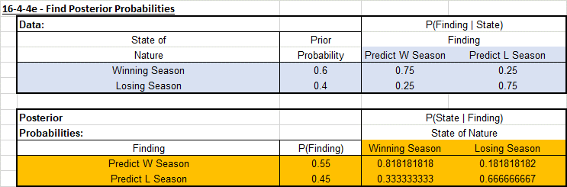

16.4.4 f)

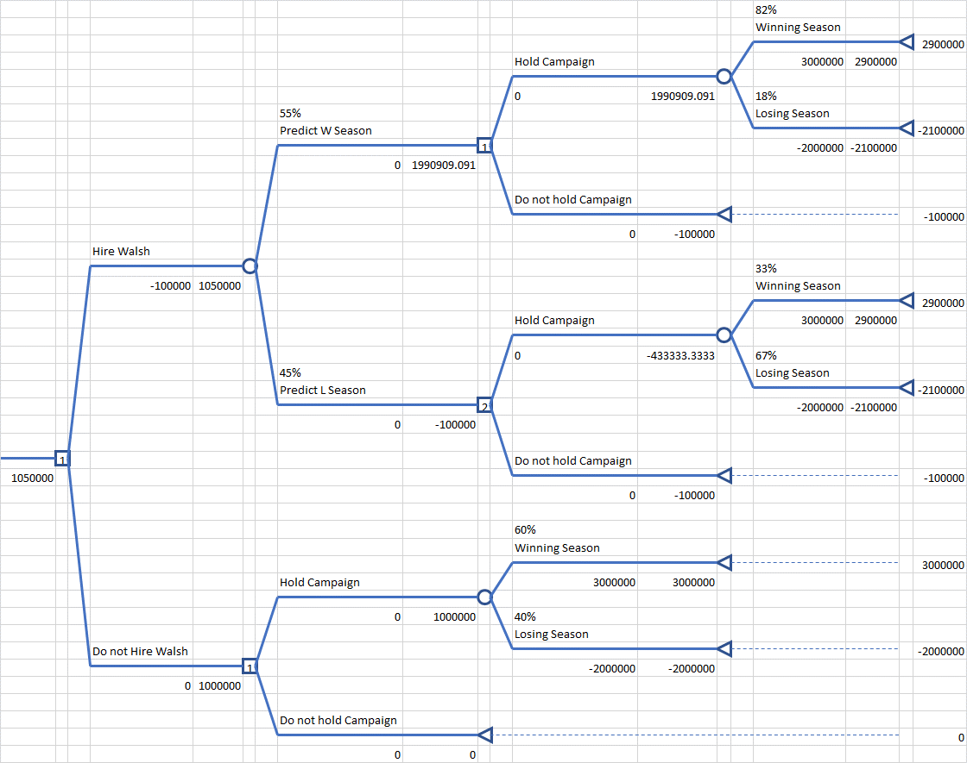 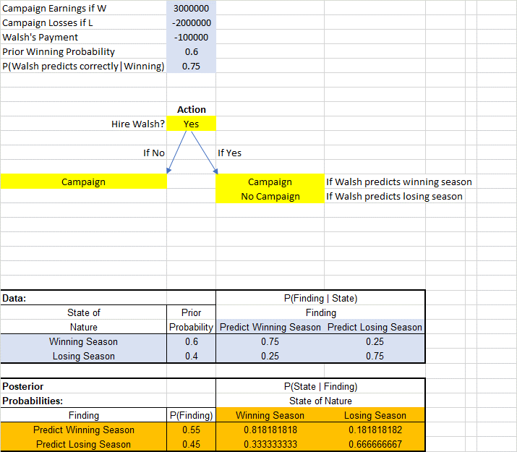

16.5.2 a)

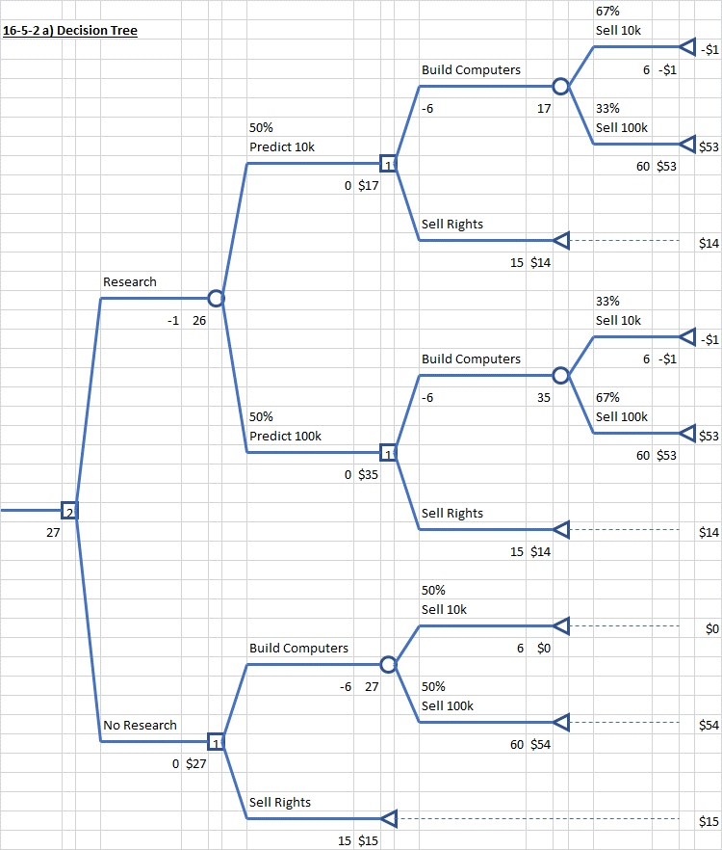

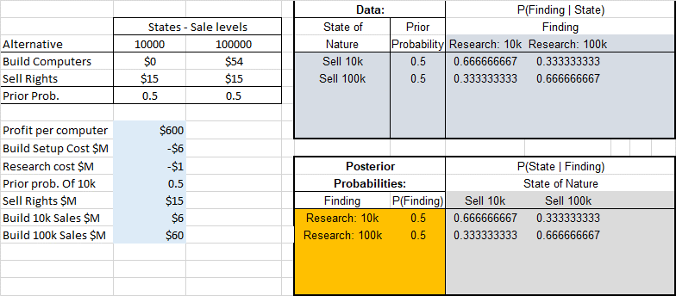

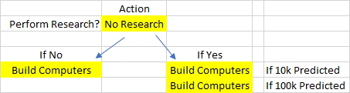

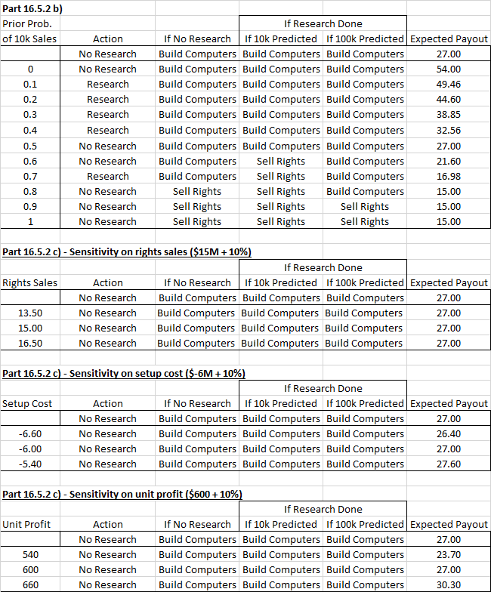

Two way analysis, cases 1-4:

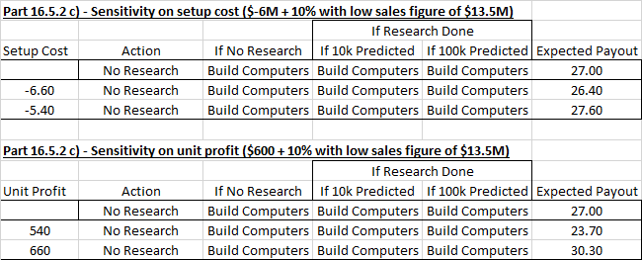

Two way analysis, cases 5-8:

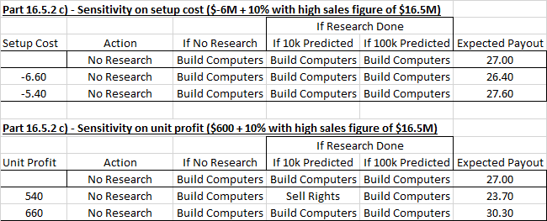

**16-6-1 a)**



**16-6-1 b)**

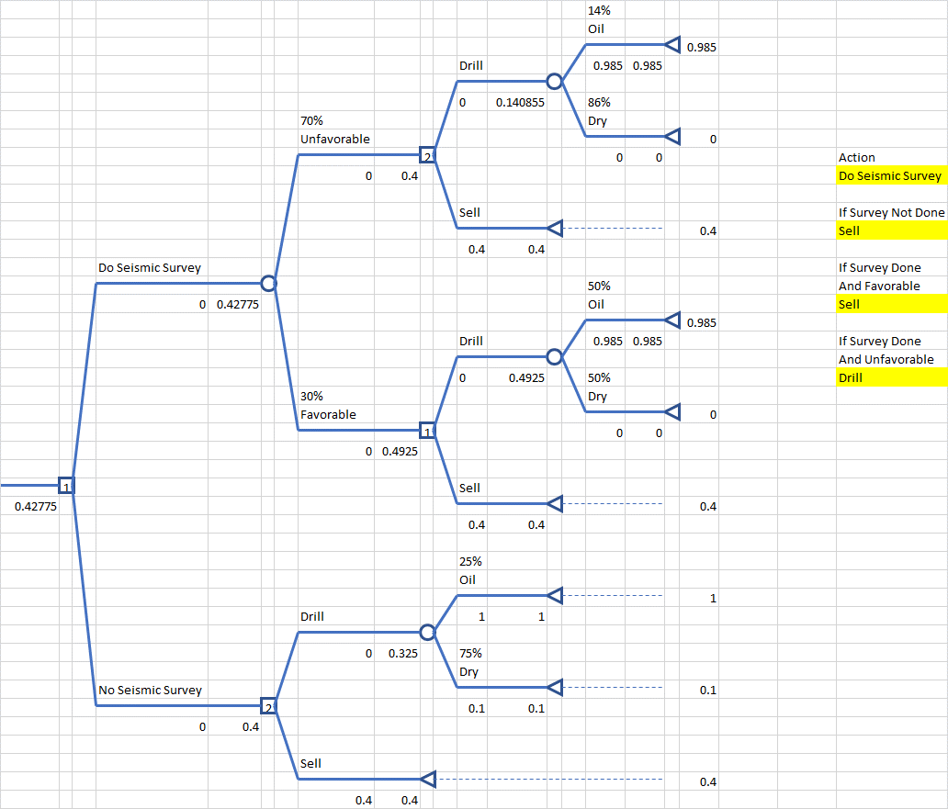

**16.6.3)**

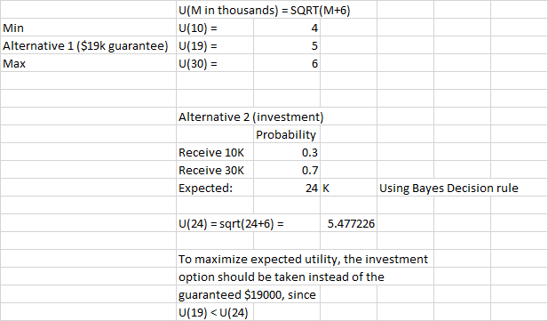

**16.6.6 b - .25)**

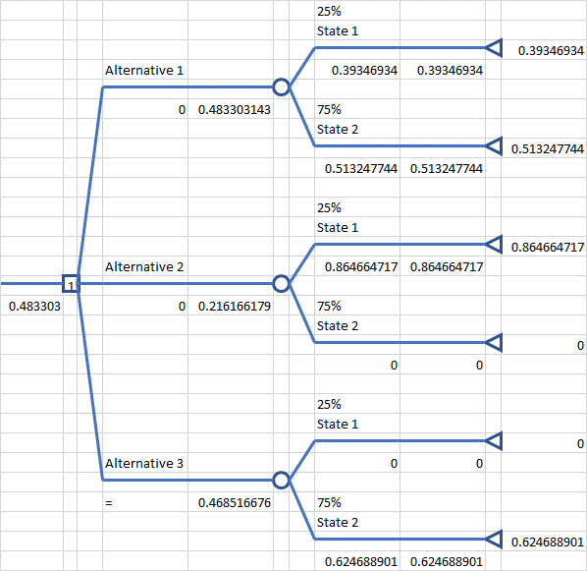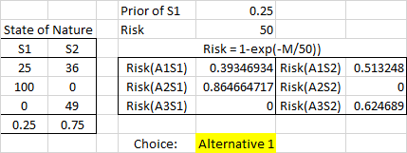

**16.6.6 b - .50)**

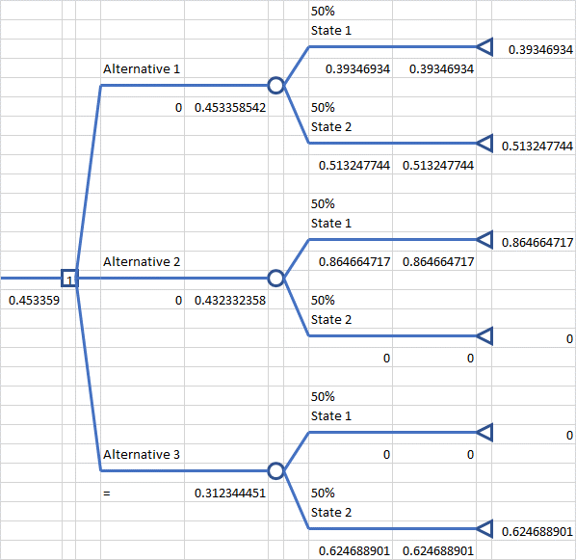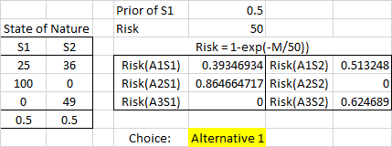

**16.6.6 b - .75)**

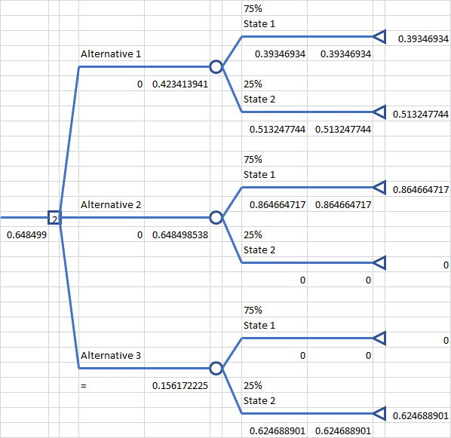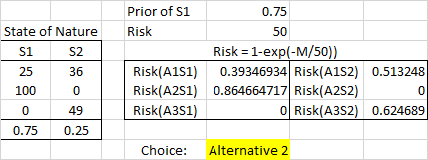

**16.6.7 (See spreadsheet for decision tree, too large to be legible in word document)**

